Week 3 Portfolio and learning reflective

Exercise | Evidence of Completion (Screenshot Reference) | What I Learned | Challenges or Errors Encountered | How I Solved the Problem | Key Skill Developed
Exercise 1: JavaScript Functions | 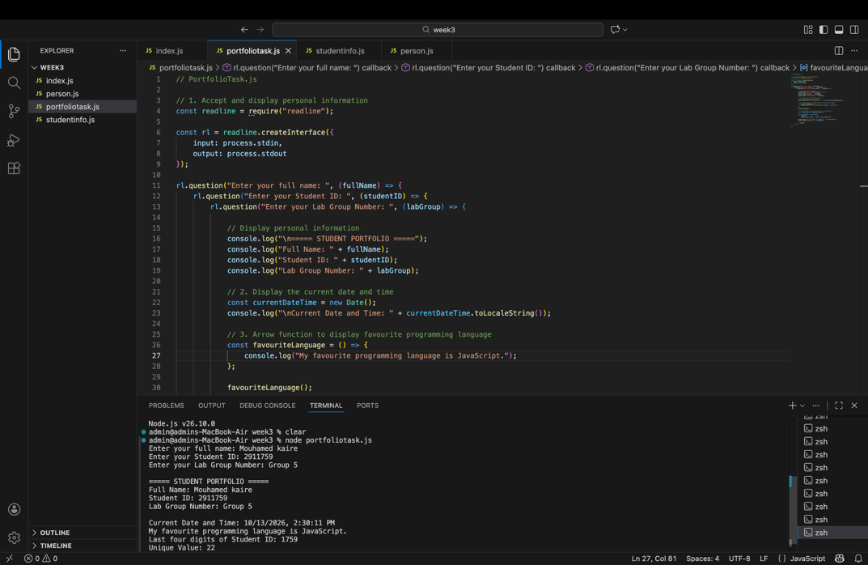 | I learned how to create and use JavaScript functions to perform specific tasks. I also learned how to use parameters, return values, and variables in a program. | I initially found it difficult to understand how functions work and how to call them correctly. | I reviewed the example code, checked the function syntax, and tested my program to understand how the functions returned values. | JavaScript programming, problem-solving, and understanding functions.
Exercise 2: Arrow Functions |  | I learned how to write arrow functions using the => syntax. I understood how arrow functions can simplify JavaScript code and return values. | I initially found it challenging to understand the syntax of arrow functions and how they differ from regular functions. | I practiced writing arrow functions and compared them with regular functions. I tested the functions to check that they produced the expected output. | Writing concise JavaScript code and understanding different function types.
Exercise 3: Local Modules | 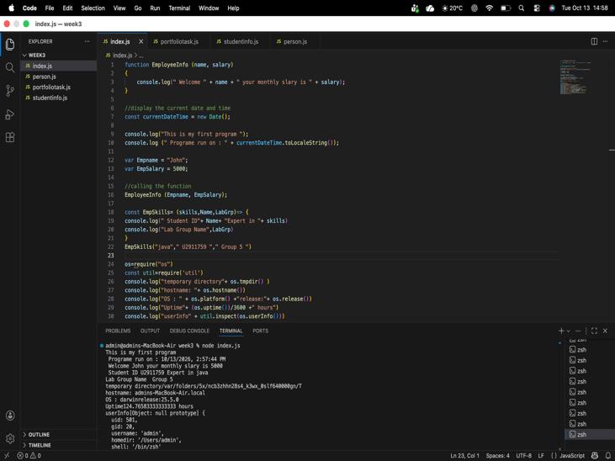  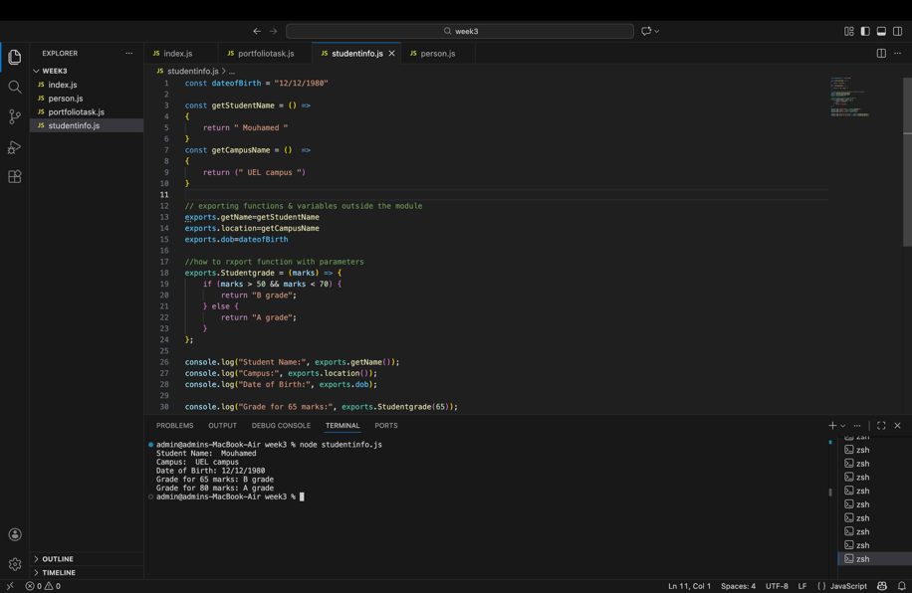 | I learned how to organize JavaScript code into separate files and reuse functions and variables from other files. I also learned how to export and import functionality between local modules. | I found it challenging to understand how to export functions and variables from one file and access them in another file. | I checked the module syntax and ensured that the exported function names matched the names used when importing or accessing them in another file. I then ran the program using Node.js to test it. | Modular programming, code organization, and code reuse.
Exercise 4: Node.js Core Modules |  | I learned that Node.js provides built-in modules that allow JavaScript programs to perform tasks outside a web browser. I practised using the core modules demonstrated in the lab exercises. | I initially found it difficult to understand how to use Node.js core modules and access their functionality correctly. | I reviewed the lab examples, checked the module syntax, and ran the program in the terminal to verify the output. | Node.js programming, using built-in modules, and debugging.
PortfolioTask.js | 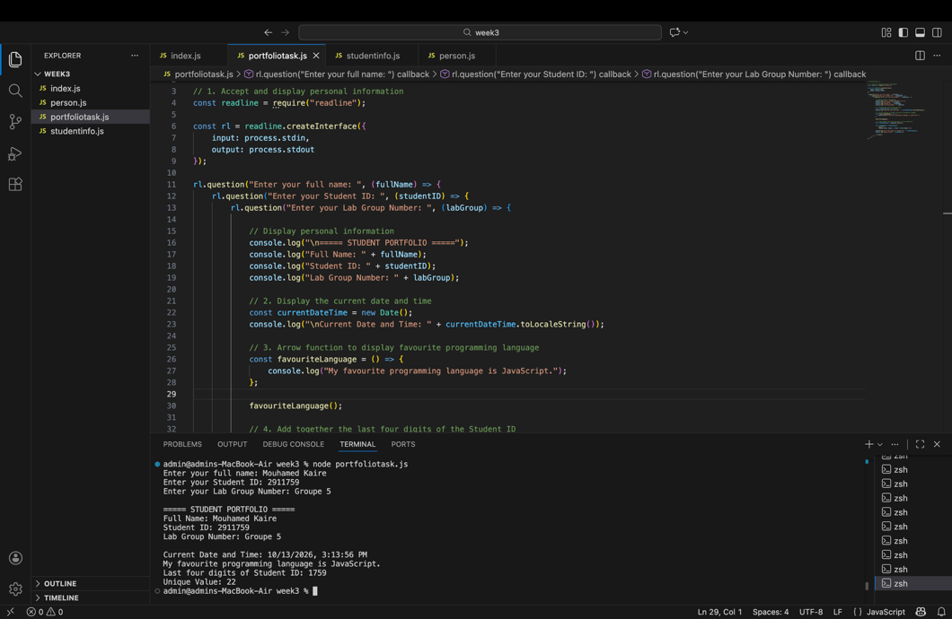 | I learned how to combine variables, functions, arrow functions, and arithmetic operations in a JavaScript program. I also learned how to display personal information and the current date and time. | I needed to ensure that the program displayed all the required information correctly and calculated the verification number using the last four digits of my Student ID. | I checked the program requirements, corrected any syntax errors, and ran the JavaScript file using Node.js. I compared the terminal output with the expected results to verify the program. | JavaScript programming, arithmetic operations, debugging, and executing programs with Node.js.

